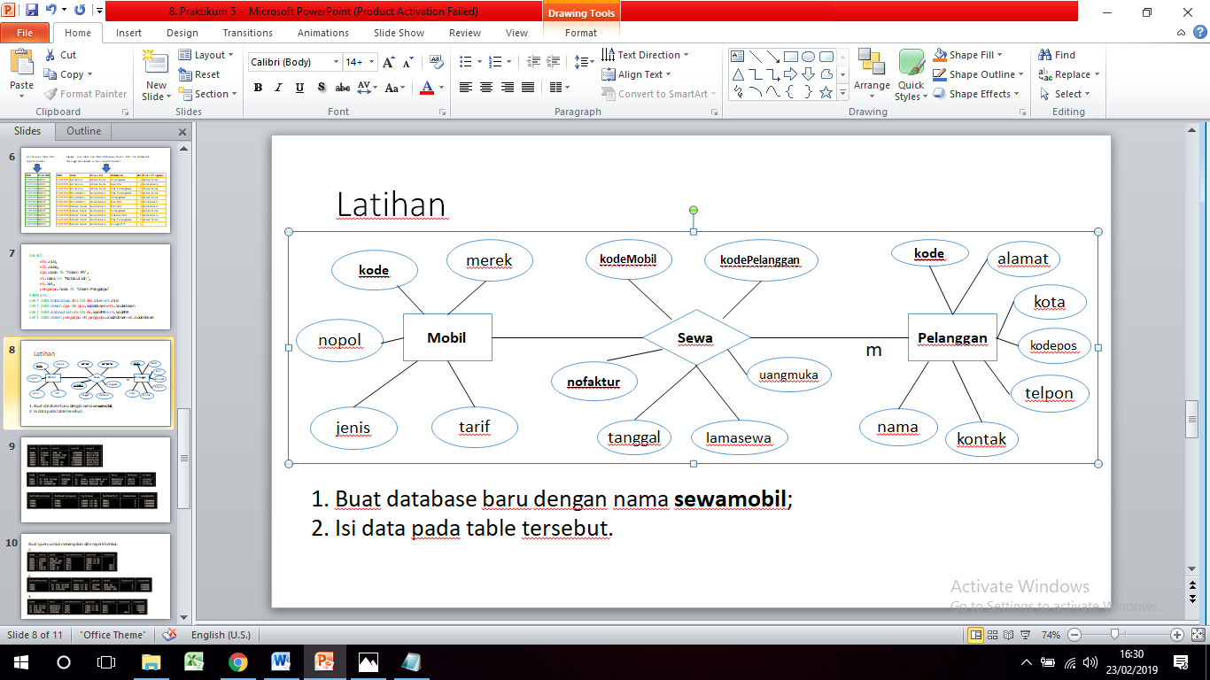Praktikum 5

Data model maping

Table mobil

|  |  |  |  |  |
| --- | --- | --- | --- | --- |
| Kode | jenis | merk | tarif | sewa |

Table sewa

|  |  |  |  |  |  |  |
| --- | --- | --- | --- | --- | --- | --- |
| kode | nama | kontak | alamat | kota | kodepos | telepon |

Table Pelanggan

|  |  |  |  |  |  |
| --- | --- | --- | --- | --- | --- |
| nofaktursewa | kodepelanggan | Tglsewa | kodemobil | lamasewa | uangmuka |